**Salesforce Developers**

**Basic Knowledge Test: 1**

**Name: Vania Kostiuk**

**Skype: hakamaza99**

**Phone: +38(093)114-52-07**

**Note:** All test tasks should be completed in well-structured code/ scripts applying Java, Vanilla JS, SQL best practices and Code Conventions.

1. Your DB needs to hold two main objects – **Contacts** and **Organizations**. Each Contact can work in several organizations and each Organization has a lot of contacts.   
     
   - What type of relationship would you use?   
   - Draw the scheme of all tables with relationships.

Relationship Name: many-to-many  
  
  
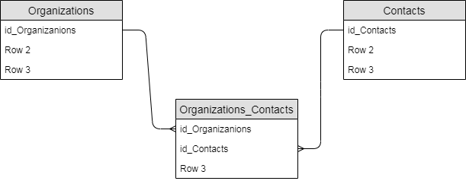

<https://github.com/VaniaKostiuk/Test_for_dev_Kostiuk>

1. Now we have DB with each **Contact** has the only one related **Organization**.   
     
   - How can you find all contacts with **Name** starts with *“A”* in organization named *“Cats”*?   
   - How can you count number of contacts for each organization?   
   - Write SQL query for each question above.

1: SELECT Contact.name , Organization.name FROM Contact INNER JOIN Organization

ON Contact.id = Organization.id

AND Organization.name = 'Cats'

AND Contact.name LIKE 'A%' ;  
  
  
  
  
  
  
  
2: SELECT Organization.name, COUNT(Contact.name) AS CountContact

FROM Organization LEFT JOIN Contact

ON Organization.id = Contact.idCompany

GROUP BY Organization.name ;

<https://github.com/VaniaKostiuk/Test_for_dev_Kostiuk>

1. As a part of project, you need to implement functionality of calculating salaries for employees in different companies. Each company have its own salary budget. Every employee has his own hourly rate and work hours. Basic formula for salary calculation is ratePerHour * workdays * 8

Each company should have ability to pay salaries to its workers. We should take into consideration that total salary payments can’t be greater than company wage budget. UML diagram listed below.

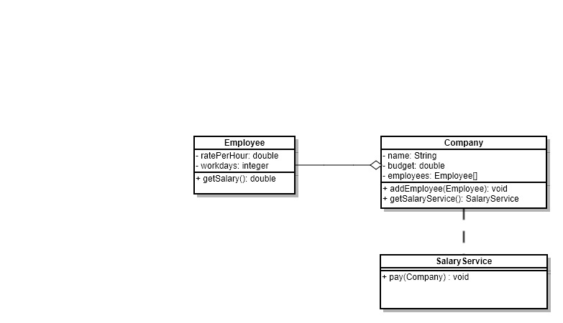

1) Write classes that implement this diagram.   
2) You should have at least 3 types of employees  
e.g.

Manager

Developer

Scrum master

Developer may have bonuses that should be add to the basic salary, it should be taken into consideration during calculation of his wage.

<https://github.com/VaniaKostiuk/Test_for_dev_Kostiuk>

1. You have a list of numbers to fill the table of prices in the shown way

|  |  |  |  |  |  |  |  |  |  |  |  |  |
| --- | --- | --- | --- | --- | --- | --- | --- | --- | --- | --- | --- | --- |
|  | **Jan** | **Feb** | **Mar** | **Apr** | **May** | **Jun** | **Jul** | **Aug** | **Sep** | **Oct** | **Nov** | **Dec** |
| Prod. 1 | Num1 | Num2 | Num3 | Num4 | Num5 | Num6 | Num7 | Num8 | Num9 | Num10 | Num11 | Num12 |
| Prod. 2 | Num13 | Num14 | … |  |  |  |  |  |  |  |  |  |
| Prod. 3 |  |  |  |  |  |  |  |  |  |  |  |  |

- Implement Java method which receive this list and return the object which will be convenient to find price using Month and Product keys.

<https://github.com/VaniaKostiuk/Test_for_dev_Kostiuk>

1. Given todo list in file ‘Test_Backend_4’.

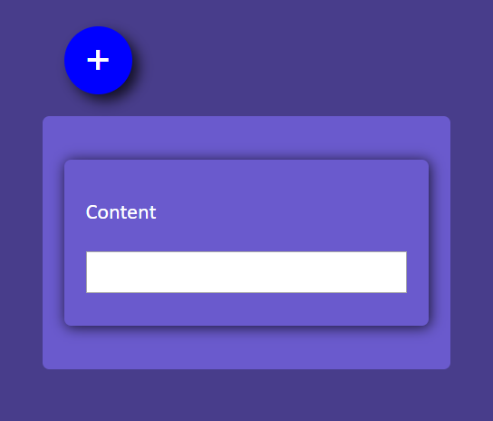

Implement following tasks using javaSript:

* 1. creation of the toDo list item (click on ‘+’ button).

<https://github.com/VaniaKostiuk/Test_for_dev_Kostiuk>

1. Why have you chosen to be developer? Describe your main objectives and hopes about your future carrier.

I've decided to become a developer for a few simple reasons.

I wanted to change my previous job, as I realised that I wasn't enjoying what I was doing anymore. Also, I'm highly interested in self-development in this area and would like to earn more as a specialist.

For the future, I want to work for the interesting projects to improve my programming knowledge and skills.

So, I'm ready to study and work hard to gain an opportunity to become a part of the CTDev team in the position of Salesforce developer.